Full Stack Stock Market Simulation Platform
Project Documentation — MERN Stack

1. Introduction

Project Title
SB Stocks — a virtual stock trading and portfolio simulation web application.
Team Leader
- Anagani Veera Siva Kumar

Team Members

Rishitha Bommidi

Venkata Kishore Nalabothula

Farzana Mohammad

Karthik Parasa

2. Project Overview

Purpose
SB Stocks lets a user practice stock trading in a risk-free, simulated market. On signing up, each user is credited with $100,000 in virtual cash, which they can use to buy and sell shares of well-known public companies at live-simulated prices, track portfolio performance, maintain a watchlist, and review past trades — without any real money changing hands.

Key Features
- User registration and login with email/password
- Live-simulated stock market with auto-updating prices, daily % change, and traded volume
- Search stocks by company/symbol, filter by sector, and sort (e.g. by company name, price)
- Paginated stock listing (e.g. "Page 1 of 2")
- Buy shares via a confirmation modal showing current price, total cost, available balance, and remaining balance after purchase
- Sell shares directly from the Portfolio page
- Portfolio dashboard showing total portfolio value, total investment, and overall gain/loss (₹ / $ and %)
- Per-holding profit/loss (P/L) shown in green (gain) or red (loss)
- Watchlist to star/track favorite stocks without buying
- Transaction history log of past trades
- User profile management — update name, email, password, and profile image URL
- Account summary showing virtual balance and account role (User/Admin)
- Light/Dark mode toggle
- Toast notifications confirming actions (e.g. "Bought 1 share(s) of AMZN")
- Seeded demo admin account for first-time access

3. Architecture

Frontend
Built with React. The UI follows a dashboard layout with a persistent left sidebar (Dashboard, Stocks, Portfolio, Watchlist, Transactions, Profile) and a top bar showing the app logo, a dark-mode toggle, and the logged-in user's avatar/name. Component-level state drives modals (e.g. the Buy dialog) and live-updating price ticks on the Stocks page.

Backend
Built with Node.js and Express.js (standard for the MERN stack), exposing a REST API consumed by the React frontend for authentication, stock data, trading, watchlist, and profile operations. Passwords stored in the database are bcrypt-hashed (visible as $2a$10$... hashes in the users collection), indicating the backend uses bcrypt for credential hashing and very likely issues a session token (e.g. JWT) on login.

Database
MongoDB (hosted on MongoDB Atlas). The live database inspected during the demo contains the following collections:
Collection | Purpose | Observed Fields
users | Stores registered users and the seeded admin | _id, name, email, password (bcrypt hash), role (admin/user), balance, profileImage, status, createdAt, updatedAt, __v
stocks | Master list of tradable stocks and simulated prices | symbol, company name, sector, current price, % change, volume (inferred from UI)
portfolios | Per-user holdings | _id, userId (ref), stockId (ref), quantity, averagePrice, createdAt, updatedAt, __v
transactions | Buy/sell trade history | userId (ref), stockId (ref), type (buy/sell), quantity, price, timestamp (inferred from UI)
watchlists | Stocks starred by a user | userId (ref), stockId (ref) (inferred from UI)

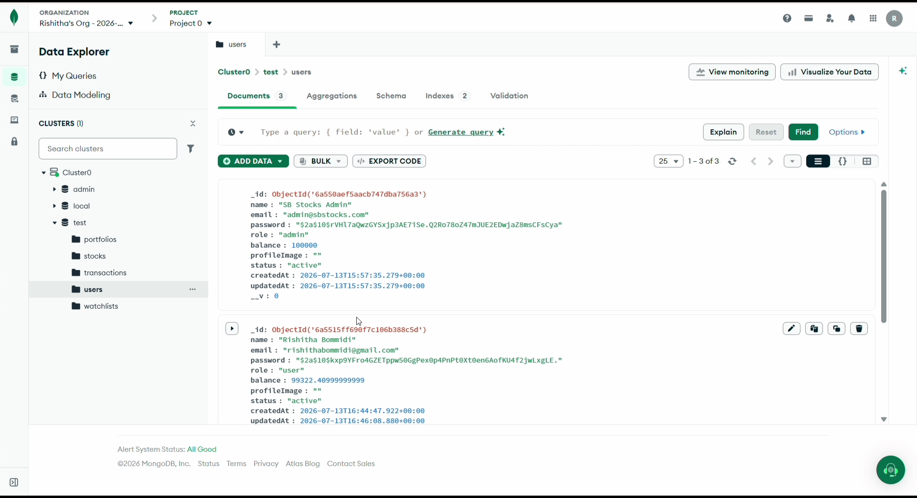
MongoDB Atlas — 'users' collection showing hashed passwords, role, and balance fields
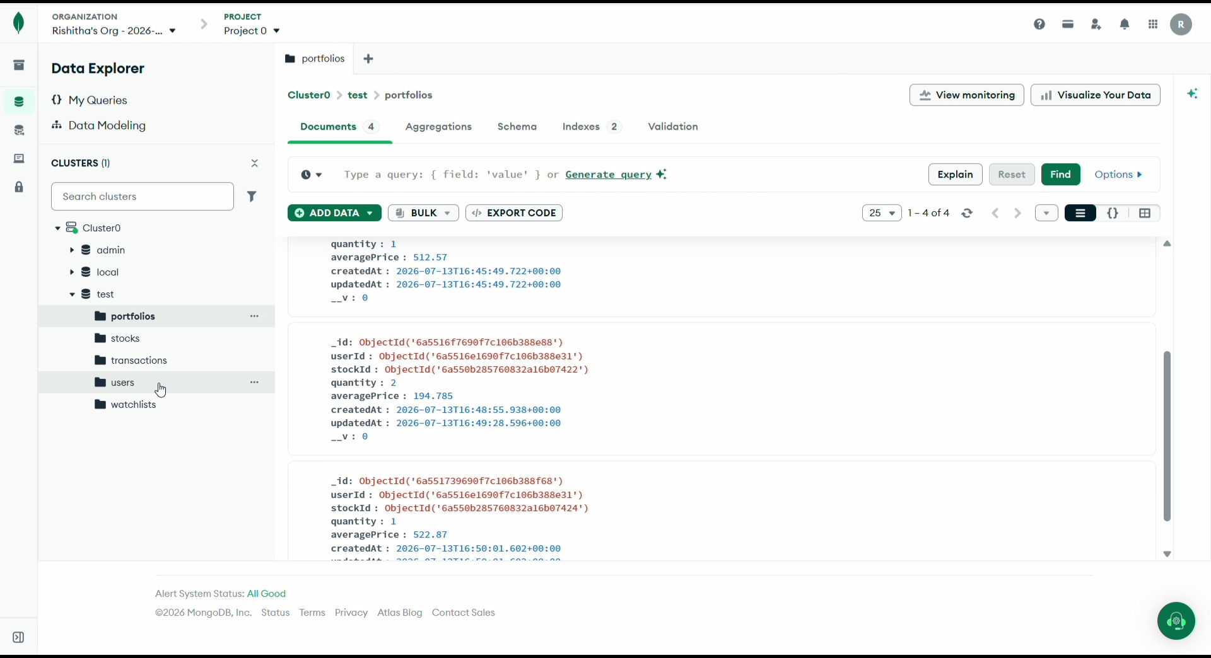
MongoDB Atlas — 'portfolios' collection linking userId and stockId with quantity and averagePrice

4. Setup Instructions

Prerequisites
- Node.js (v18 or later recommended)
- npm (bundled with Node.js)
- MongoDB (local instance or a MongoDB Atlas connection string)
- Git

Installation
- Clone the repository: git clone <repository-url>
- Install server dependencies: cd server && npm install
- Install client dependencies: cd client && npm install
- Create a .env file in the server directory with at least:
  - MONGO_URI=<your MongoDB connection string>
  - JWT_SECRET=<your secret key>
  - PORT=<server port, e.g. 5000>
- (Optional) Run the database seed script to create the demo admin account (admin@sbstocks.com / Admin@123) and populate sample stocks.

5. Folder Structure

Client (React frontend)
- client/src/components — Reusable UI components (stock card, buy/sell modal, navbar, sidebar)
- client/src/pages — Route-level pages: Login, Signup, Dashboard, Stocks, Portfolio, Watchlist, Transactions, Profile
- client/src/context or store — Global state (auth/user session, theme)
- client/src/services or api — Axios/fetch wrappers for backend API calls
- client/public — Static assets

Server (Node.js / Express backend)
- server/models — Mongoose schemas: User, Stock, Portfolio, Transaction, Watchlist
- server/routes — Express route definitions (auth, stocks, portfolio, watchlist, transactions, users)
- server/controllers — Business logic for each route group
- server/middleware — Auth/JWT verification, error handling
- server/seed — Database seeding script for demo admin/stocks
- server/server.js — Application entry point

6. Running the Application
- Backend: from the server directory, run npm start (or npm run dev if using nodemon).
- Frontend: from the client directory, run npm start.
By default the React app runs on http://localhost:3000 and proxies API requests to the Express server (commonly http://localhost:5000).

7. API Documentation.
Method | Endpoint | Description
POST | /api/auth/register | Create a new user account with starting $100,000 virtual balance
POST | /api/auth/login | Authenticate a user and return a session/JWT token
GET | /api/stocks | List all stocks with live-simulated prices (supports search/sector filter/sort/pagination)
GET | /api/stocks/:id | Get details for a single stock
POST | /api/portfolio/buy | Buy shares of a stock; deducts cost from balance and updates portfolio
POST | /api/portfolio/sell | Sell shares of a stock; credits proceeds to balance
GET | /api/portfolio | Get the logged-in user's holdings, total value, investment, and gain/loss
GET | /api/watchlist | Get the logged-in user's watchlist
POST | /api/watchlist/:stockId | Add a stock to the watchlist
DELETE | /api/watchlist/:stockId | Remove a stock from the watchlist
GET | /api/transactions | Get the logged-in user's transaction history
GET | /api/users/profile | Get the logged-in user's profile and account summary
PUT | /api/users/profile | Update profile (name, email, password, profile image)

8. Authentication
Authentication is handled with email/password credentials. Passwords are hashed with bcrypt before being stored — the users collection shows hashes in the standard $2a$10$... bcrypt format rather than plaintext. On successful login the backend most likely issues a JSON Web Token (JWT) that the frontend stores (e.g. in memory or localStorage) and attaches to subsequent API requests to identify the logged-in user and protect routes.
Two account roles were observed: "admin" (the seeded demo account, admin@sbstocks.com) and "user" (regular signups). The admin role likely unlocks additional privileges, though none were demonstrated in the recorded demo..

9. User Interface

Login
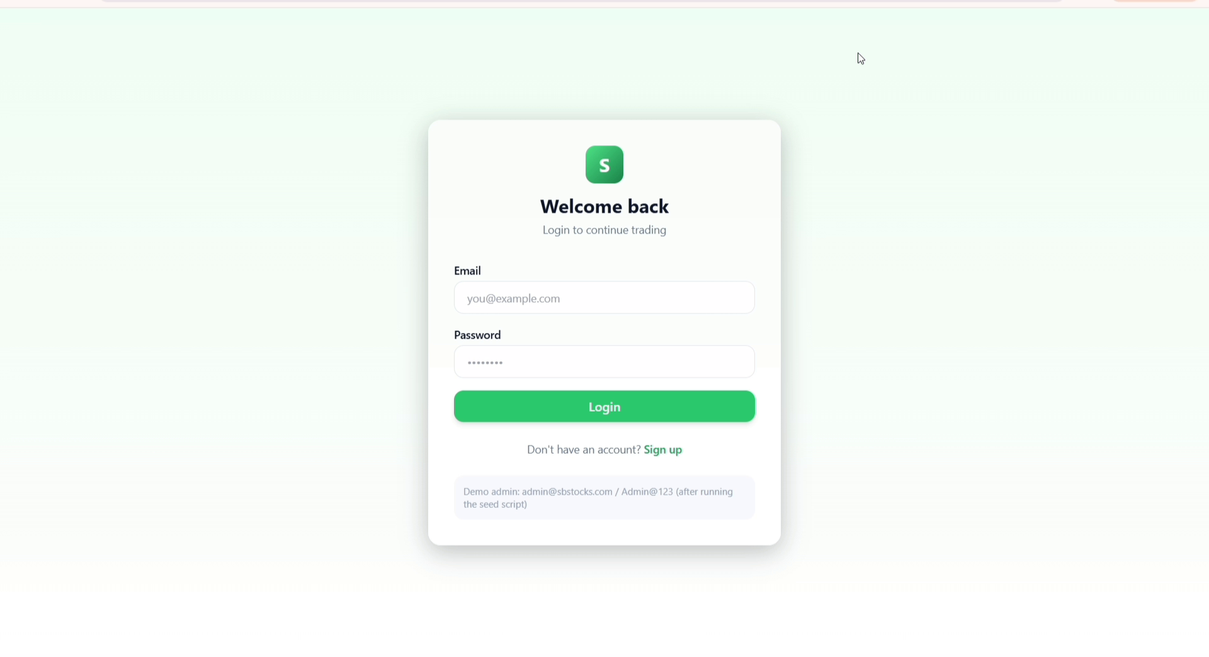
Login screen with demo admin credentials shown

Sign Up
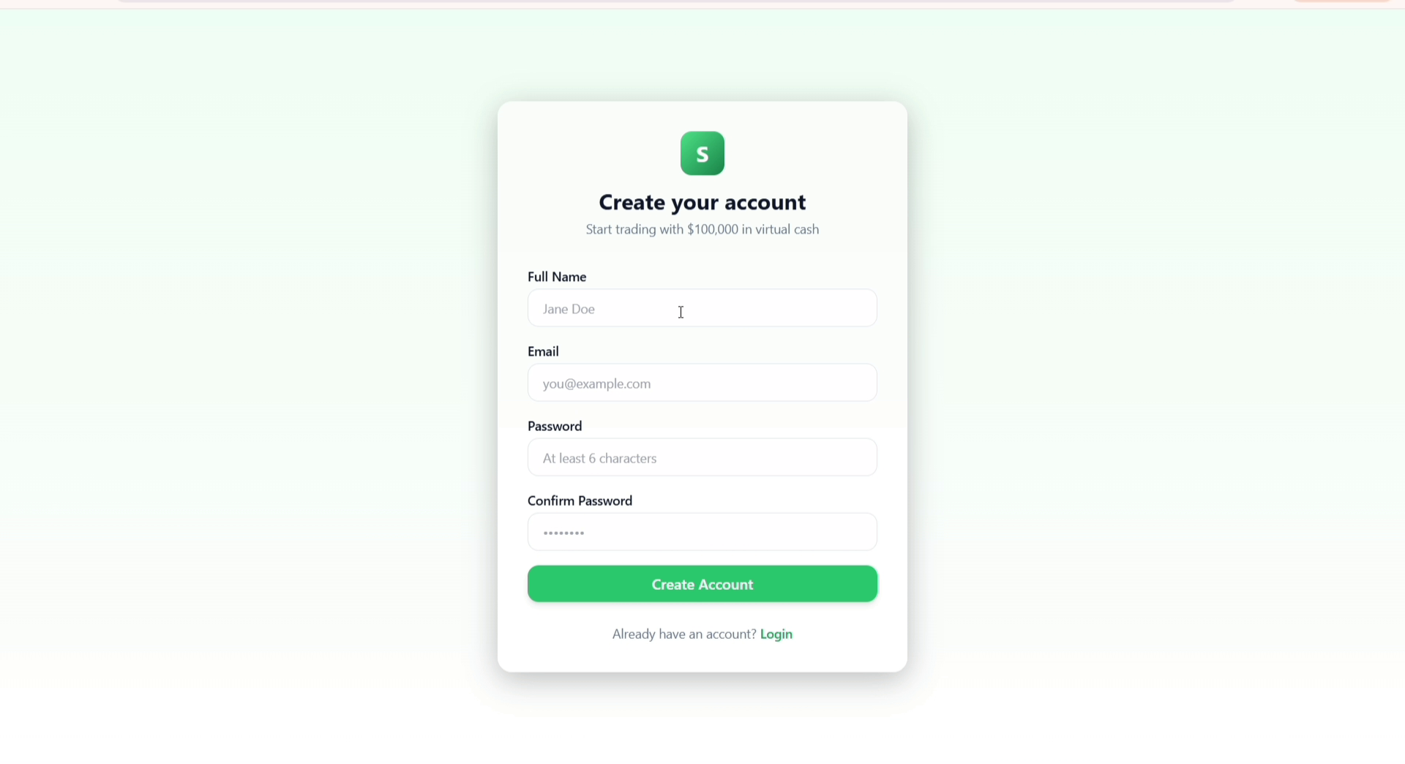
Account creation screen — new users start with $100,000 in virtual cash

Stock Market
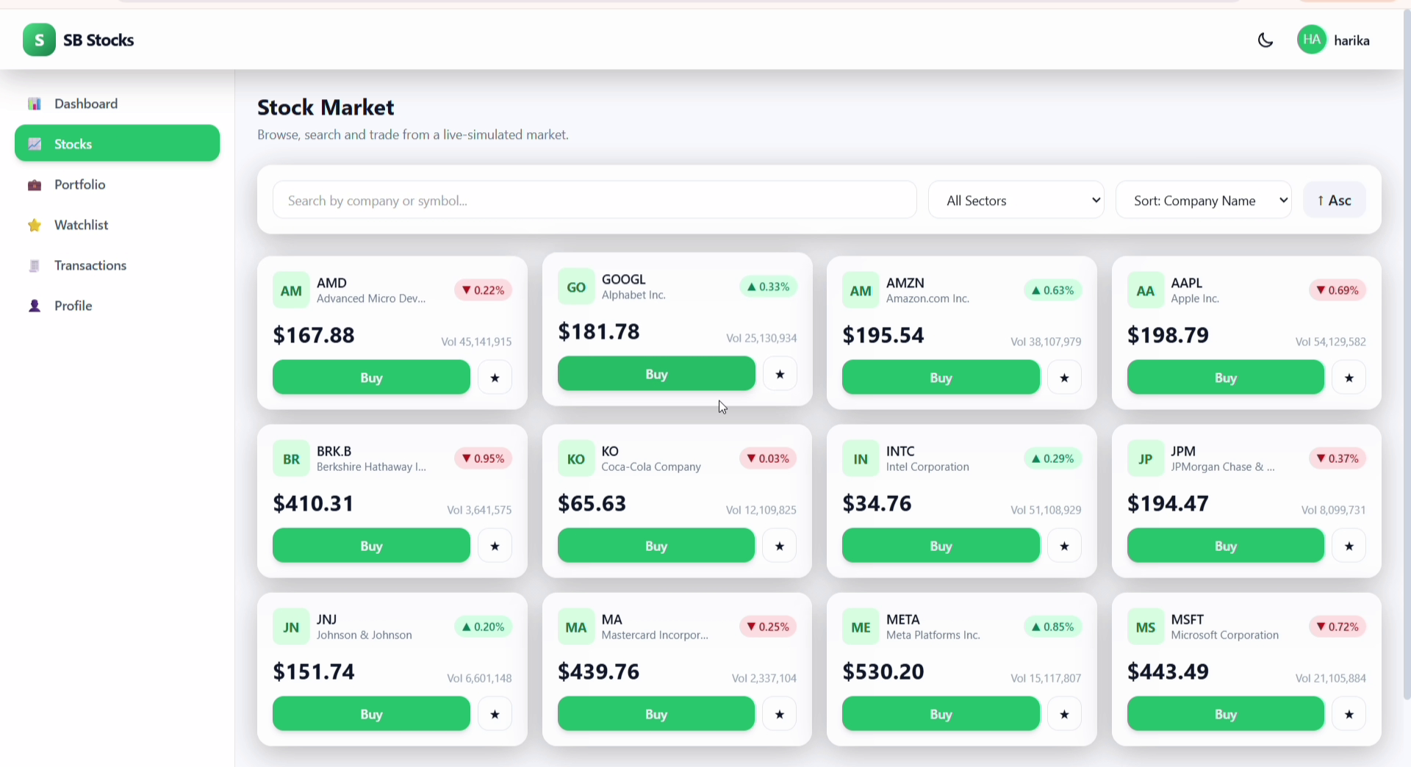
Stock Market page — live-simulated prices, search, sector filter, sort, and pagination

Buy Stock
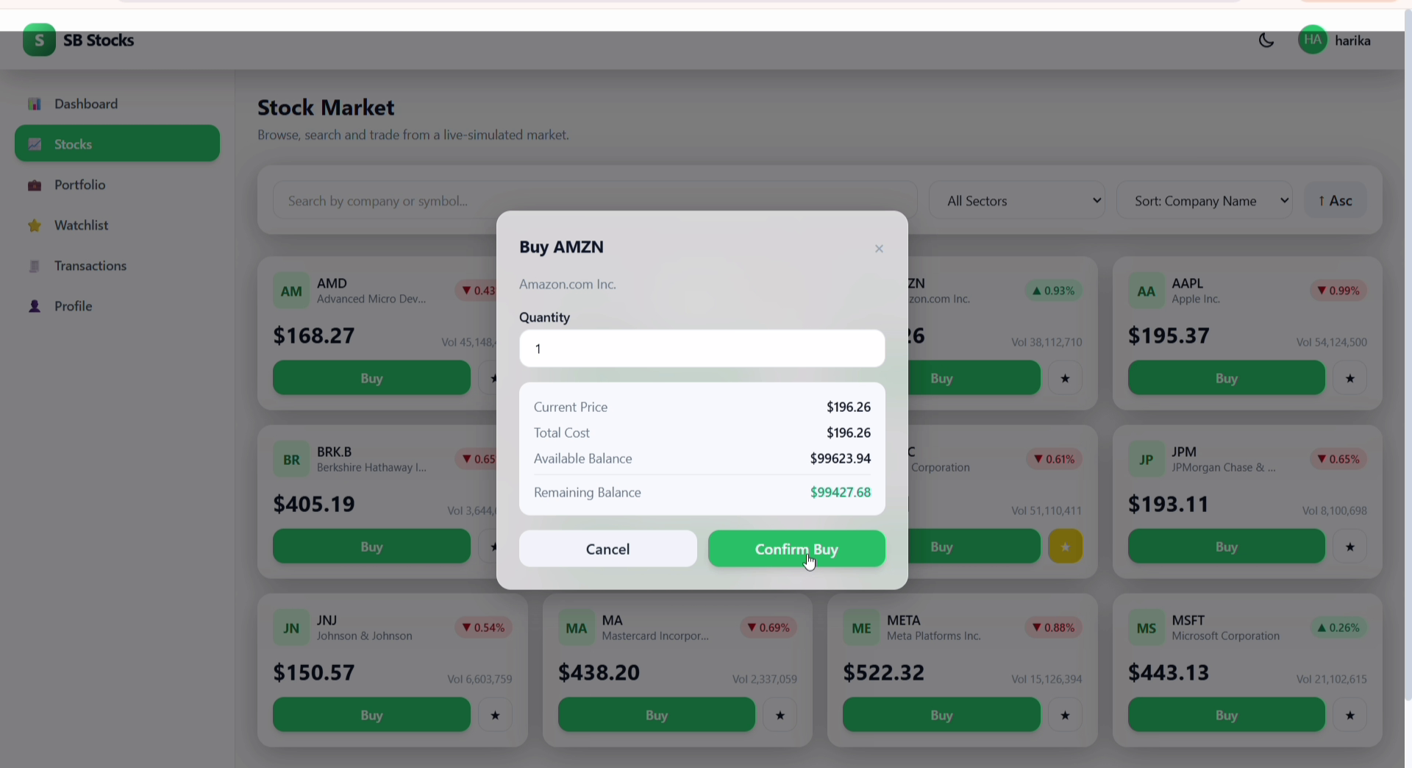
Buy confirmation modal showing cost breakdown and remaining balance

Portfolio
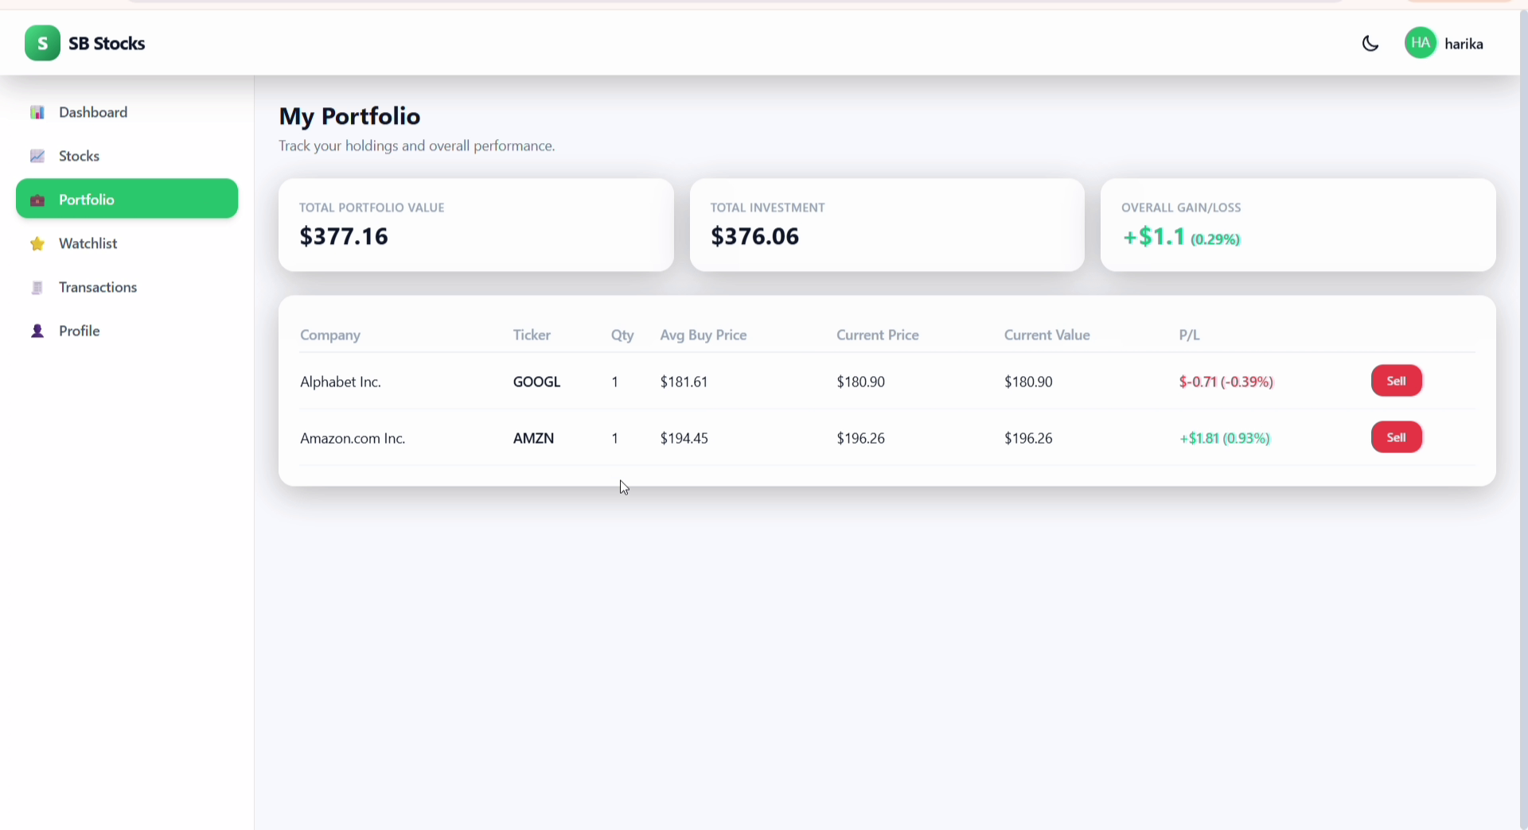
Portfolio page — total value, investment, gain/loss, and per-holding P/L with Sell action

Watchlist
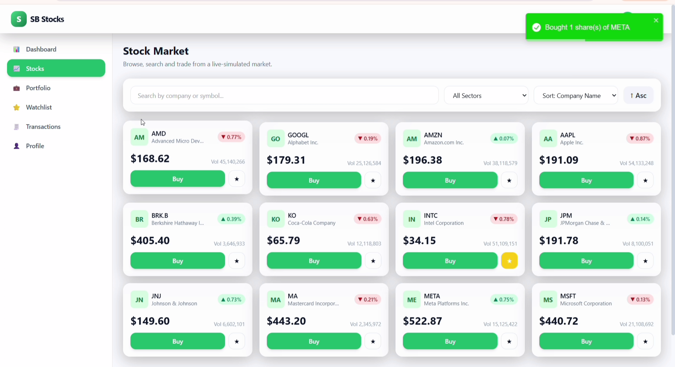
Stocks page with a stock starred/added to the Watchlist

Profile
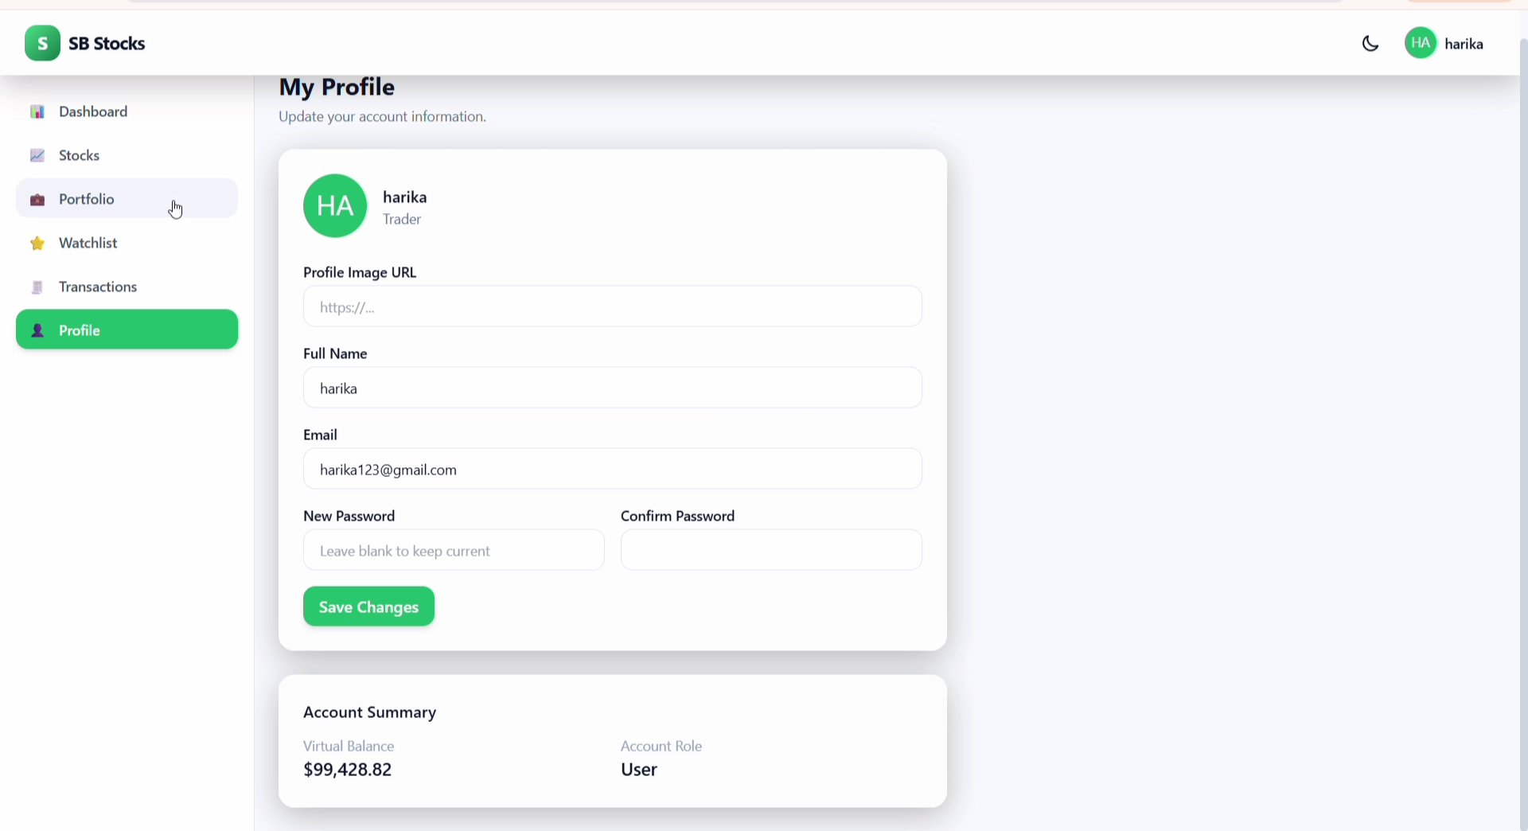
Profile page — edit personal details and view account summary (balance, role)
10. Testing
No automated test suite was visible in the demo. Recommended testing strategy for this type of MERN application:
- Unit tests for backend controllers/services (e.g. Jest) covering buy/sell balance calculations
- Integration tests for API routes (e.g. Supertest) covering auth, trading, and watchlist flows
- Component/UI tests for React (e.g. React Testing Library) covering forms and the buy modal
- Manual QA of edge cases: insufficient balance on buy, selling more shares than owned, duplicate signups

11. Screenshots or Demo
A full walkthrough is available in the accompanying demo recording (SdStocksDemo.mp4), which covers account creation, browsing the stock market, buying shares, viewing the portfolio, editing the profile, and inspecting the underlying MongoDB Atlas collections. Key frames from that recording are included throughout Section 9 above.

12. Known Issues
- Exact bug list not available without access to the project's issue tracker/source code.
- Simulated prices update automatically, which can cause the price shown at confirmation time to differ slightly from the price at click time — worth double-checking the buy modal locks in a price correctly.
- [Add any known bugs specific to this build]

13. Future Enhancements
- Price history charts (candlestick/line) for individual stocks
- Leaderboard comparing portfolio performance across users
- Real-time price updates via WebSockets instead of polling
- Limit orders / stop-loss orders in addition to market buy/sell
- Push/email notifications for watchlisted stock price alerts
- Two-factor authentication and password-reset via email
- Admin dashboard for managing users and the stock catalog

